**LEACH PROTOCOL ENHANCEMENT FOR INCREASING WSN LIFETIME**

**ABSTRACT:**

WSNs have been one of the most widely used methods in a variety of uses, including agriculture, factory inspection, health care, and fire detection. WSN is a television network that broadcasts in has many benefits, including low cost, compact scale, and ease of use. multifunctional, self-organizing, and capable of WSN routing standard operating procedures WSN, on the other hand, has several drawbacks, obstructs certain uses, such as those with a reduced battery life or a short lifespan. Sensor deployment area and sensor energy consumption .In this case, we suggest a new strategy for achieving improved results. In terms of network lifetime and data, WSN can be improved.

Index Terms: WSN, LEACH Protocol, Secondary Cluster Head, Network Lifetime, Energy Efficient.

**EXISTING SYSTEM:**

* The first proposed clustering protocol is the LEACH (LOW ENERGY ADAPTIVE CLUSTERING HIERARCHY) protocol. The operation of LEACH protocol consists of several rounds with two phases in each: Set-up Phase and Steady Phase.
* The Set-Up Phase where Cluster Heads are chosen and Cluster Formation are done. In steady state Phase the data transmission takes place between nodes to CH and CH to BS.The main idea is to choose the CH in a clustered manner at each round and then have the nodes join the closest CH to form a dynamic cluster. This network topology is built on the chosen CHs, which is inefficient due to the lack of consideration for node residual energy.  Furthermore, prioritising CH selection results in the forming of complex clusters at each round, resulting in an increase in energy overhead due to cluster formation after each re-selection phase for CHs.

**DISADVANTAGES:**

* 1. One of the biggest disadvantage of LEACH is that when due to any reason Cluster head dies, the cluster will become useless because the data gathered by the cluster nodes would never reach its destination i.e. Base Station.
* 2. CH selection is the most difficult part of dynamic clustering.
* 3. LEACH disregards the BS and cluster head geographical positions, energy consumption.
* 4. We have noticed that the cluster head missions are more than the ordinary nodes, so the cluster head consumes more energy than the others which one of the drawbacks of the LEACH algorithm.

**PROPOSED METHOD:**

* A new algorithm named S-LEACH is used to extend the existence of the system. Cluster Head (CH) and Secondary Cluster (SC) are two options for creating a network. Secondary Cluster Head (SCH) during each round's sensor configuration process. According to previous studies, the shorter the gap, the better. Among CH and BS, the BS has a longer lifespan and is more energy consuming. It's the network. We chose to pick the basis equation. The closest node to the BS is designated as CH, and the closest node to the CH is designated as SCH, taking into account the energy and distance parameters of nodes. Depending on this suggestion, if the CH dead the cluster will not cut off the communication with the sink and the secondary cluster head replace the dead cluster head and pronounces itself as a cluster head. Rather than that, the cluster continuously connecting the sink as long as the active node alive in the cluster.

.

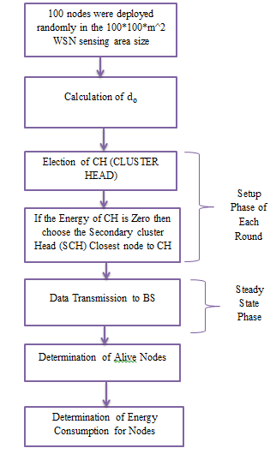

**Block diagram of proposed method**

**ADVANTAGES:**

* 1.If the CH is dead, the secondary cluster head replace the dead cluster head and pronounces itself as a cluster head.
* 2.The nearest the distance between CH and BS, the better lifetime and energy-efficient the network is. CH is selected which is nearest to BS.
* 3.In S-LEACH, the lifetime of the network is improved by selecting Cluster Head (CH) and Secondary Cluster Head (SCH) in the sensor setup phase of each round.
* 4. Secondary Cluster Head (SCH) is selected nearer to Cluster Head so there is no more energy consumption problem.
* 5. Some nodes are not able to join the cluster because they have not the range ratio of any cluster, so they connect to BS directly without electing CH by the protocol which called Direct transmission (DTx).

**APPLICATIONS:**

1.industrial control

2.environmental monitoring,

3. military surveillance,

4.intelligent transportation systems and medical field.

5.Furthermore, it can function independently in harsh or high-risk places where human presence is not possible

6.Disaster relief operations.

7.Biodiversity mapping

8.monitoring of temperature, pressure, and humidity..

**Software & Hardware Requirements:**

**Software:** Matlab R2018a.

**Hardware:**

**Operating Systems:**

• Windows 10

• Windows 7 Service Pack 1

• Windows Server 2019

• Windows Server 2016

**Processors:**

Minimum: Any Intel or AMD x86-64 processor

Recommended: Any Intel or AMD x86-64 processor with four logical cores and AVX2 instruction set support

**Disk:**

Minimum: 2.9 GB of HDD space for MATLAB only, 5-8 GB for a typical installation

Recommended: An SSD is recommended a full installation of all Math Works products may take up to 29 GB of disk space

**RAM:**

Minimum: 4 GB

Recommended: 8